Project Proposal On
Bank Management System with Real-Time Fraud Detection

Guided By:- Created By:-
Anuj Kumar Name AF_id
Tushar Sharma AF04991839
Yashark Vikal AF04990815
Uttkarsh Mavi AF04991809

Batch code :- ANP-D2405
Course code :- ITPR

Table Of Contents

Index

- Title of theProject……………………………

- Introduction……………………………………

- Objective

- Project Category

- Analysis

  - Modules and Description
  - Database Design
  - ER Diagram
  - Data Flow Diagram

- Complete Structure

  - Process Logical Diagram

- Platform Used

  - Hardware Requirement
  - Software Requirement

- Future Scope

- Bibliography

1. Title of the Project
Bank Management System with Real-Time Fraud Detection

2. Introduction
The Bank Management System with Real-Time Fraud Detection is a modern
Java-based console (CLI) application developed using Java, JDBC, MySQL, and Maven. This system is designed to manage digital banking operations efficiently, such as customer onboarding, account management, transactions, loan processing, and security monitoring.
In today’s banking environment, millions of digital transactions occur every second. To handle this efficiently, banks require fast, secure, and automated systems. This project integrates core banking functionalities with an advanced fraud detection module that continuously analyzes transactions in real time and identifies suspicious behavior using predefined rules.
The goal of this system is to provide:
- Fast and secure transaction processing

- Centralized customer and account management

- Automated loan and EMI handling

- User authentication and role-based access

- Real-time fraud alerts for high-risk transactions

- A reliable backend system built with Java and MySQL

This project demonstrates how modern banks internally handle accounts, customers, security, fraud detection, and data storage using clean programming architecture and stable database connectivity

3. Objective
- To make daily banking tasks simple and automatic, such as adding customers, creating accounts, depositing, withdrawing, and transferring money.

- To store all banking information in one place, so customer, account, loan, and transaction details can be accessed easily.

- To make the system secure, by using login, roles (admin/employee), and by keeping track of user activities.

- To detect fraud in real time, so whenever a suspicious transaction happens, the system can immediately generate an alert.

- To make loan and EMI management easy, including loan application, EMI calculation, and EMI payment records.

- To make banking operations fast and accurate, reducing manual work and avoiding common mistakes.

- To build a system using Java, JDBC, and MySQL, which can be expanded in the future by adding more features.

- To maintain a well-structured database, so that all records (customer, accounts, loans, transactions, and alerts) remain consistent, accurate, and easy to manage.

4. Project Category
This project falls under the category of Software Development (Java Application). It is a Console-Based Banking System built using the following technologies:
- Core Java for logic implementation

- JDBC (Java Database Connectivity) for connecting Java with MySQL

- MySQL Database for storing and managing all banking data

- Maven for project management and dependency handling

5. Analysis
→ Modules and Description :-

⭐ 1. Customer & Account Management Module
This module handles all customer-related and account-related operations.
Functions:
- Add new customer

- Update customer details

- Store customer KYC

- Create account (Savings / Current / Salary)

- View account details

- Link customer with account

📌 Purpose: To maintain complete records of customers and their accounts.

⭐ 2. Transaction Management Module
This module manages all types of money transactions inside the bank.
Functions:
- Deposit amount

- Withdraw amount

- Transfer money between accounts

- Show mini statement

- Show full transaction history

- Record each transaction in the database

📌 Purpose: To process daily banking transactions accurately and securely.

⭐ 3. Loan & EMI Management Module
This module handles loan-related operations.
Functions:
- Apply for a loan

- Store loan details

- Calculate EMI

- Pay EMI

- Track overdue EMIs

- Store loan types (Home, Car, Personal, etc.)

📌 Purpose: To manage long-term loan and EMI records of customers.

⭐ 4. Fraud Detection Module
This module detects suspicious activities in real time.
Functions:
- Check high-amount transactions

- Detect too many transactions in a short time

- Identify repeated login failures

- Generate fraud alerts

- Store all suspicious activities in fraud database

📌 Purpose: To improve banking security and protect accounts from fraud.

● ⭐ 5. Authentication & User Management Module
This module manages system users (admin, manager, employee).
Functions:
- Admin login

- Role-based login

- Password verification

- Track failed login attempts

- Manage user roles

📌 Purpose: To keep the system secure and allow only authorized users.

⭐ 6. Internal Bank Management Module
This module manages internal bank data.
Functions:
- Manage branch details

- Manage employee details

- Assign roles and departments

- Track employee activity

📌 Purpose: To maintain internal bank-level operations.

⭐ 7. Charges & Billing Module
This module handles different types of bank charges.
Functions:

- Maintenance charges

- Loan processing fee

- Penalty charges

- GST / Service charges

📌 Purpose: To automatically deduct charges and store billing records.

- Database Design (MySQL)

⭐ Table No. 1: customer

field | datatype | properties | description
customer_id | int | primary key,not null | Unique id for each customer
customer_name | varchar(100) | not null | Customer full name
email | varchar(100) | unique , not null | Customer email address
mobile | varchar(15) | not null | Customer mobile number
address | varchar(255) | not null | Customer residential address

Relation: One customer can have many accounts

⭐ Table No. 2: customer_kyc

field | datatype | properties | description
kyc_id | int | Primary key, not null | Unique id for KYC record
customer_id | int | Not null, foreign key | Linked customer id
aadhaar_no | varchar(20) | Not null | Customer Aadhaar number
pan_no | varchar(20) | Not null | Customer PAN number
address_proof | varchar(255) | Not null | Address proof document
kyc_status | vbarchar(20) | Not null | KYC verification status

Relation: One customer has one KYC record

⭐ Table No. 3: account

field | datatype | properties | description
account_no | int | Primary key, not null | Unique account number
customer_id | int | Not null, foreign key | Linked customer id
account_type_id | int | Not null, foreign key | Linked account type
balance | double | Not null | Current account balance
status | varchar(20) | Not null | Account status  (active/closed/frozen  )

Relation: One customer can have multiple accounts

⭐ Table No. 4: account_type

field | datatype | properties | description
account_type_id | int | Primary key, not null | Unique account type  id
type_name | varchar(50) | Not null | Name of account type  (Savings/Current/Sa  lary)

Relation: One account_type is assigned to many accounts

⭐ Table No. 5: transaction

field | datatype | properties | description
txn_id | int | Primary key, not null | Unique transaction  id
account_no | int | Not null, foreign key | Linked account number
amount | double | Not null | Transaction amount
txn_type_id | int | Not null, foreign key | Transaction type
txn_time | timestamp | Not null | Date and time of transaction

Relation: One account can have many transactions

⭐ Table No. 6: transaction_type

field | datatype | properties | description
txn_type_id | int | primary key, not null | Unique transaction type id
type_name | varchar(50) | not null | Name of transaction type  (Deposit/Withdraw/T ransfer)

Relation: One transaction type is used by many transactions

⭐ Table No. 7: bank_branch

field | datatype | properties | description
branch_id | int | primary key, not null | Unique branch id
branch_name | varchar(100) | not null | Name of the bank branch
branch_address | varchar(255) | not null | Address of the branch

Relation: One transaction type is used by many transactions

⭐ Table No. 8: loan_details

field | datatype | properties | description
loan_id | int | primary key, not null | Unique loan id
customer_id | int | Not null, foreign key | Linked customer id
loan_type_id | int | Not null, foreign key | Linked loan type
loan_amount | double | not null | Principal loan amount
interest_rate | double | not null | Loan interest rate
tenure_months | int | not null | Loan tenure in months

Relation: One customer can have multiple loans

⭐ Table No. 9: loan_type

field | datatype | properties | description
loan_type_id | int | primary key, not null | Unique loan type id
type_name | varchar(50) | Not null | Name of loan type  (Home/Car/Personal  )

Relation: One loan type is used by many loans

⭐ Table No. 10: emi_payment

field | datatype | properties | description
emi_id | int | primary key, not null | Unique EMI id
loan_id | int | not null, foreign key | Linked loan id
emi_amount | double | not null | EMI amount to be paid
payment_date | date | not null | EMI payment date
status | varchar(20) | not null | EMI status  (paid/pending/overd ue)

Relation: One loan has many EMI payments

⭐ Table No. 11: fraud_alert

field | datatype | properties | description
alert_id | int | primary key, not null | Unique alert id
txn_id | int | not null, foreign key | Linked transaction id
reason | varchar(255) | not null | Reason for fraud alert
alert_time | timestamp | not null | Time of alert generation

Relation: One transaction can generate multiple fraud alerts

⭐ Table No. 12: employees

field | datatype | properties | description
employee_id | int | primary key, not null | Unique employee id
branch_id | int | not null, foreign key | Linked branch id
name | varchar(100) | not null | Employee full name
role | varchar(50) | not null | Employee role  (Manager/Clerk/etc.)
departement | varchar(50) | not null | Employee department
email | varchar(100) | unique, not null | Employee email
mobile | varchar(15) | not null | Employee mobile number

Relation: One branch can have many employees

⭐ Table No. 13: users

field | datatype | properties | description
user_id | int | primary key, not null | Unique user id
employee_id | int | not null, foreign key | Linked employee id
username | varchar(50) | unique, not null | Login username
password | varchar(255) | not null | Login password
role | varchar(50) | not null | User role  (Admin/Manager/Em ployee)
status | varchar(20) | not null | Account status (active/inactive)

Relation: One employee can have one user login

⭐ Table No. 14: login_failed_attempts

field | datatype | properties | description
attempt_id | int | primary key, not null | Unique attempt id
user_id | int | not null, foreign key | Linked user id
attempt_time | timestamp | not null | Time of failed login
reason | varchar(255) | not null | Reason for login failure

Relation: One user can have multiple failed login attempts

● ER Diagram
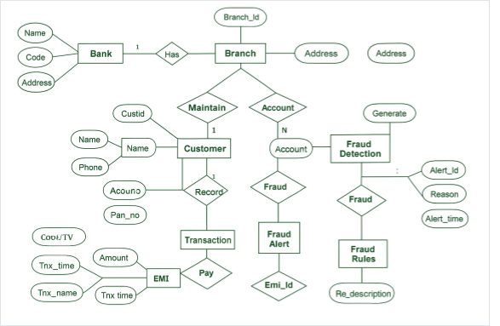

● Data Flow Diagram
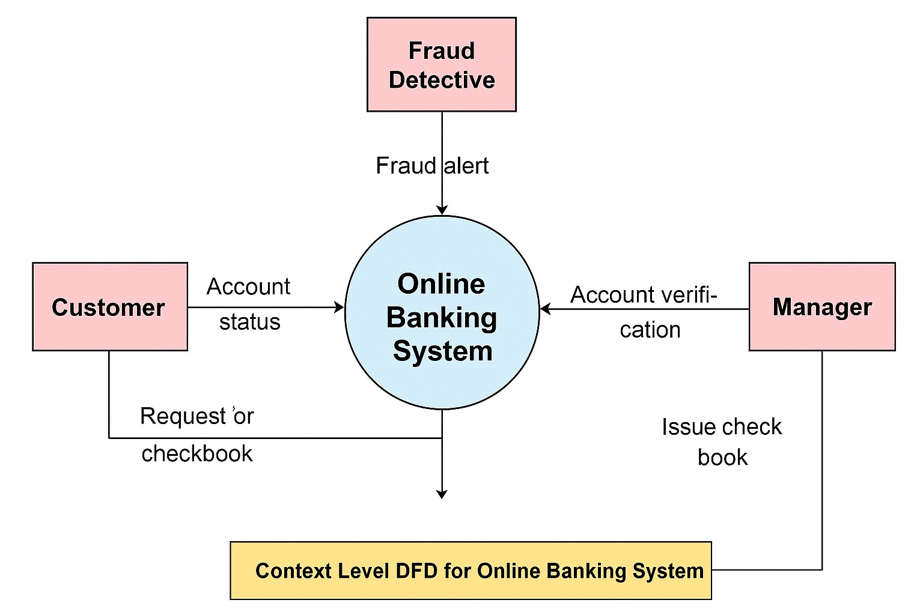

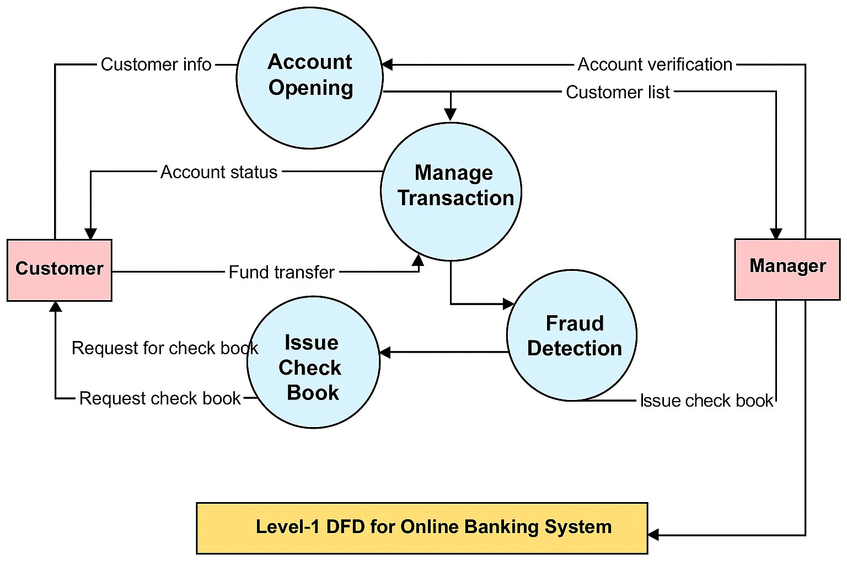

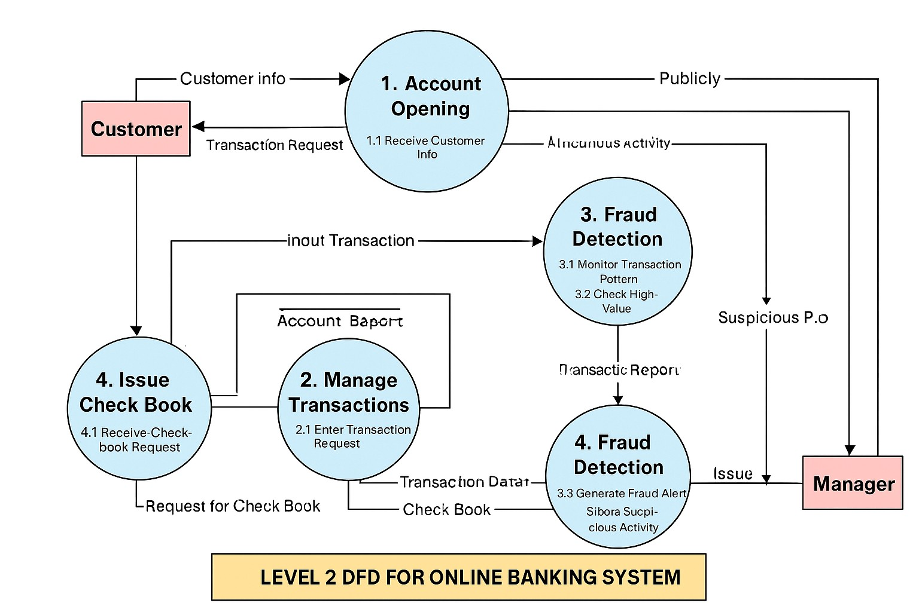

6. Complete Structure

● Process Logical Structure

Login
↓
Dashboard
↓
Customer Management → Account Management → Transaction Management
↓
Loan & EMI → Fraud Detection (Real-Time) → User & Authentication
↓
Branch Management → Employee Management → KYC Verification
↓
Reports & Statements → Logout

7. Platform Used

Hardware Requirements

- Processor: Intel i5
- RAM: 16GB
- Storage: 1GB free

Software Requirements

- Windows
- JDK 17+
- MySQL Server
- MySQL Workbench
- Maven
- IDE: Eclipse

8. Future Scope (For Bank + Fraud Detection System)
- AI-Based Fraud Prediction
- Mobile Banking App Integration
- Biometric Login System
- Automated Loan Approval Using AI
- Cloud-Based Banking System
- Blockchain-Based Transaction Security
- Real-Time Credit Card Fraud Detection
- Chatbot-Based Customer Support
- Advanced Risk Scoring Engine
- Geo-Location Based Fraud Alerts

⭐ 9. Bibliography (For This Project)
- MySQL Documentation
Used for designing relational database and SQL queries.
- JDBC API Documentation
Used for connecting Java application with MySQL database.
- Java Official Documentation (Oracle Docs)
Core Java, OOPs, exception handling, collection framework.
- OWASP Security Guidelines
Authentication, authorization, and security rules for fraud prevention.
- GeeksforGeeks
Concepts and examples related to Java, JDBC, and DS/Algo.
- Maven Project Documentation
Used for project dependency management and folder structure.
- Research Papers on Fraud Detection
Understanding AI/ML techniques for detecting financial fraud.
- Banking Domain Standards (RBI Guidelines)
Transaction limits, KYC norms, and security compliance research

